Leaving Cert Physics Worked Solutions 2019

2019 Question 1

- Draw a labelled diagram of the apparatus used in the experiment.
timer, ball and release mechanism, pressure plate
- Between which points was the distance s measured?
From bottom of ball to top of pressure plate

- Describe how the time t was measured.
timer started when ball released and stopped when it hit plate
- Draw a suitable graph that can be used to determine the acceleration due to gravity g.
s (cm) | 30.0 | 40.0 | 50.0 | 60.0 | 70.0 | 80.0 | 90.0
t (ms) | 250 | 285 | 310 | 345 | 380 | 400 | 435
s (m) | 0.3 | 0.4 | 0.5 | 0.6 | 0.7 | 0.8 | 0.9
t ² (s²) | 0.063 | 0.081 | 0.096 | 0.119 | 0.144 | 0.160 | 0.189

values for t ²
labelled axes (3)
points plotted
straight line of good fit

- Hence determine g.
slope formula / correct substitution into slope formula
slope calculated: slope $≈5$
acceleration due to gravity calculated: slope ≈ 10 m s⁻²

- A small, dense ball was used as the object in this experiment. State an advantage of using this type of ball.
less air resistance

2019 Question 2

- How did the student find the approximate focal length?
found image of a distant object
- Why did the student find the approximate focal length at the start of the experiment?
to ensure object was placed outside of focal point / so a real image could be formed / image formed on a screen / to compare with later answer
- Describe, with the aid of a labelled diagram, how the position of the image was found.
concave mirror, screen and object
correct arrangement
move screen (and/or object and/or mirror) until (sharpest) image is formed
- State two precautions that should be taken when measuring v.
error of parallax, measure to back of mirror, measure to centre of mirror, sharp image formed
- Use all of the data to calculate the focal length of the mirror.
$$\frac{1}{u}+\frac{1}{v}=\frac{1}{f}$$

values of f: 15.1, 14.9, 15.0, 14.5 cm
average: 14.9 cm

2019 Question 3

In an experiment to determine the specific latent heat of fusion of ice, a student first crushed some ice.
She then dried the melting ice before adding it to warm water in an insulated copper calorimeter.
The following data were recorded.
Mass of copper calorimeter = 56.3 g
Mass of calorimeter and water before adding ice = 108.5 g
Initial temperature of water = 29.5 °C
Final temperature of water = 8.0 °C
Mass of calorimeter and water after adding ice = 122.9 g

- Why did the student crush the ice?
to ensure it was all at the same temperature / to ensure it was all at 0°C / so that it would melt faster / to give a greater surface area
- Why did the student dry the ice?
to ensure that only ice was added to the calorimeter
- How was the ice crushed?
e.g ice crusher

- How was the ice dried?
using a towel
- Why did she use warm water?
ice would melt more quickly / so that energy lost = energy gained
- Why did she use melting ice?
to ensure that the ice was at 0°C
- Use the data to calculate the specific latent heat of fusion of ice.
∆θ_{ice} = 8, ∆θ_{water} = 21.5, m_{water} = 52.2 grams
ml + (mc∆θ)_{water} = (mc∆θ)_{water} + (mc∆θ)_{calorimeter}

(14.4)l_{ice} + (14.4)(4180)(8) = (52.2)(4180)(21.5) + (56.3)(390)(21.5)

l_{ice} = 3.25 $×$ 10⁵ J kg⁻¹

- Why could using a very large mass of water lead to a less accurate result in this experiment?
smaller change in temperature / greater percentage error

2019 Question 4

- Draw a circuit diagram for this experiment.
source of varying voltage, diode, ammeter, voltmeter
correct arrangement
- Use the data to draw a graph of current against potential difference.
labelled axes
points plotted
curve of good fit
- Use your graph to determine the junction voltage.
≈ 0.2 V
- What happened in the diode when the junction voltage was exceeded?
depletion layer broke down / low resistance / current flows
- Is Ohm’s law obeyed for the diode? Justify your answer.
no
not a straight line through the origin
- State two other changes that are made to the circuit before recording data for a diode in reverse bias.
replace ammeter with a microammeter,
place voltmeter across diode and (micro)ammeter,
remove (protective) resistor if already included

2019 Question 5
A crane moves a load of weight 7000 N to the  top of a roof which is 4 m high.  The crane takes 20 seconds to do this work.  Calculate this distance in metres. | s = vt  s = (3.00 × 10⁸)(3.15 × 10⁷)  s = 9.45 × 10¹⁵ m
An apple has a weight of 1 N and its volume is 121 cm³.  Calculate the density of the apple.  (acceleration due to gravity = 9.8 m s^{–2})  = 843 kg⁻³ | W = mg $m=\frac{W}{g}$ m = 0.102 kg  There are 1 × 10⁶ cm³ in 1 m³  Therefore 121 cm³ = 121 × 10⁻⁶ m³  $$ρ=\frac{m}{v}=\frac{0.102}{121×{10}^{-6}}$$  = 843 kg⁻³
A book is decelerating as it moves to the right on a horizontal table.  Draw a labelled diagram to show the forces acting on the book as it moves on the table.  Solution  This is a lovely question for illustrating the fact that an object can be moving in one direction but accelerating in the opposite direction.  Why?  One more time for the people at the back – because the direction of acceleration is determined by the direction of the net force causing that acceleration (and not by the direction of motion).  If the book is decelerating then the force causing this deceleration must be in the opposite direction to its motion, so we need to put in an arrow pointing left. | 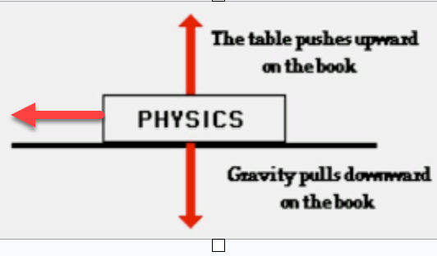
What is meant by polarisation of light? | The wave is vibrating in one plane only
What is the thermometric property of  (i) a mercury thermometer, (ii) a thermocouple? | (i) length/height/volume  (ii) emf/voltage
Sketch a graph to show the relationship between resistance R and temperature T (in °C) for a metallic conductor. | 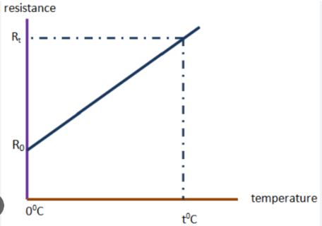
Power P is generated in a resistor of resistance R when a potential difference V is applied across it.  Write P in terms of R and V. | P = VI  Now we use I = V/R  P = V²/R
Polonium was discovered by Marie and Pierre Curie in 1898. Polonium–218 has a half‐life of 3 minutes.  Calculate the activity of a sample of polonium–218 that contains 75000 nuclei. | $T_{1/2}=\frac{ln2}{λ}$ $λ=\frac{ln2}{T_{1/2}}$ λ = 0.00385 s⁻¹  A = $λN$ = (0.00385)(75000) = 289 Bq
Polonium–218 is produced as the daughter nucleus in the alpha‐decay of radon–222.  Write a nuclear equation for this reaction. | $${Rn}_{86}^{222}→{Po}_{84}^{218}+ {He}_{2}^{4}$$
Neutrinos are sometimes called ghost particles. Why are they very hard to detect? | very small mass  no charge

2019 Question 6

- State Newton’s law of universal gravitation.
Force is proportional to product of masses and inversely proportional to distance squared
OR
Formula plus notation
- What is the relationship between the period T and radius of orbit r of a satellite?
T² proportional to R³

- Which has a longer wavelength, visible or infrared radiation?
Infrared

- Describe how infrared radiation can be detected in the school laboratory.
Heating effect / thermometer
- What is the period of METEOSAT 11?
24 hours
- Calculate its height above the surface of the Earth.
T = 24 hours = (24)(60)(60) = 86400 seconds
Mass of Earth = 6 ×10²⁴ kg
G = 6.7 x 10⁻¹¹ N m² kg⁻²

$R^{3}=\frac{{(6.7×10}^{-11})(6 ×{10}^{24})({86400)}^{2}}{{4π}^{2}}$

R = 42331000 m h = (42331000 – radius of the earth) = 3.596 × 10⁷ m = 36000 km

- Calculate its radius of orbit.
14000 km hr^{‐1} = $\frac{(14000)(1000)}{(60)(60)}$ m s⁻¹ = 3889 m s⁻¹

$v^{2}=\frac{GM}{R}$ ${3889}^{2}=\frac{{(6.7×10}^{-11})({6×10}^{24})}{R}$ $R=\frac{{(6.7×10}^{-11})({6×10}^{24})}{{3889}^{2}}$

R = 2.65× 10⁷ m

- Calculate its angular velocity.
$v=rω$ $3889=({2.65× 10}^{7})(ω)$ ω = 1.47×10⁻⁴ rad s⁻¹

- Calculate the minimum time it takes a signal to travel from the global positioning satellite to the Earth.$v=\frac{s}{t}$ ${(3.00×10}^{8})=\frac{({2.65×10}^{7}-{6.4×10}^{6})}{t}$
t = 0.067 s
- Explain why satellites remain in orbit and do not fall to Earth.
This was a horrible questions and very difficult to answer in a short time.
The marking scheme allocated full marks to anyone who simply used the word velocity!

2019 Question 7
- What is meant by potential difference?
Work done per unit charge
- State its unit.
The volt
- Define electric field strength.
Force per unit charge
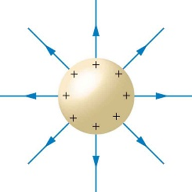
- Describe how an insulated spherical conductor can be charged positively by induction.
Bring a negatively charged rod close to the spherical conductor.
Earth the spherical conductor
Remove the earth.

- Draw the electric field around the charged conductor.
radial field lines
away from positive charge
- Calculate the charge on the conductor.
r = distance from the point in question (5 cm from the surface of conductor) to the centre of the conductor (which has a radius of 6 cm).
Total distance = 11 cm = 0.11 m

$E=\frac{Q}{4πεd^{2}}$ $2.3=\frac{Q}{4π(8.9×{10}^{-12}){(0.11)}^{2}}$ Q = 3.1×10⁻¹² C

- Explain how point discharge occurs.
Most charge accumulates on the pointed end of a conductor.
If the build-up of charge is sufficiently large, it can ionise the air around it, attracting oppositely-charged ions and repelling similarly-charged ions.
- Describe how point discharge can be demonstrated in the laboratory.
Attach a nail to the surface of a Van der Graff generator.
Bring up a candle and notice that the flame moves away from the Van der Graff. This is because of the ‘wind’ generated by point discharge.

2019 Question 8

- Distinguish between photoelectric and thermionic emission.
photoelectric: light; thermionic: heat
- What name is given to electrons emitted during radioactive decay?
beta
- What is a line emission spectrum?
(specific) frequencies/colours (of e.m. radiation) emitted by a material
- Explain, in terms of the structure of the atom, how this spectrum is produced.
energy given to electron
electron changes energy levels
photon emitted / light emitted / (e.m.) radiation emitted
- Write down Einstein’s photoelectric equation.
hf = $∅$ + ½mv²
- What physical quantity is represented by point A?
threshold frequency
- What physical quantity is represented by the slope of the graph?
Planck constant (fair play to you if you got that right – it definitely wasn’t specified on the syllabus)
- Calculate the maximum velocity of the emitted electrons when photons of energy 4.15 eV are incident on magnesium.
E_{k} = 0.47 eV = 7.5 × 10⁻²⁰ J E_{k} = ½ mv² = 7.5 × 10⁻²⁰
7.5 × 10⁻²⁰ = ½ (9.1 × 10⁻³¹)v² v = 4.1 × 10⁵ m s⁻¹

- Electrons are produced in an X‐ray tube by thermionic emission.
Where in the tube are the electrons produced?
- What is the minimum wavelength of an X‐ray produced in a 50 kV tube?
eV = hf
(1.6 × 10⁻¹⁹)(50 × 10³) = (6.6 × 10⁻³⁴)f
f = 1.2 10¹⁹ Hz Now use c = f to find the wavelength
$=2.5$ × 10⁻¹¹ m
State two design features of an X‐ray tube that take account of this.
tungsten target, cooling fluid

2019 Question 9
(a)
- Explain the underlined terms.
Force is something which can cause an object to accelerate.
Magnetic field is a region where magnetic forces are felt.

- Describe an experiment to demonstrate that a current‐carrying conductor experiences a force in a magnetic field.
Power supply, aluminium foil, magnets set up as shown.
- Turn on the power supply.
- The foil moves up (or down - depending on the direction of the current).

- When would a current‐carrying conductor in a magnetic field not experience a force?
When the conductor is parallel to the magnetic field

(b)
- Write down an expression for the force F on the current‐carrying wire in terms of I, B and the length l of the wire.
F = BIL
- Plot a graph on graph paper of force against current.
labelled axes points plotted correctly line of good fit
Convert force from mN to N by dividing by 1000
y = (m)(x) + c | Line goes through the origin so c = 0
y = (m) (x)
F = (BL) (I) | So if we plot a graph with F on the Y-axis and I on the X-axis, the slope will correspond to BL.
Slope = 0.02 and l = 3 cm = 0.03 m
0.02 = B(0.03)
B = 0.67 T
- Calculate the slope of the graph and use it to calculate the magnetic flux density of the field.
(c)
- Derive the expression F = qvB
$$F=BIl$$
$I=\frac{q}{t}$ and $v=\frac{l}{t}$
$$F=B(\frac{q}{t})(vt)$$
$$F=Bqv$$

- Calculate the force acting on the electron.
B = 0.5 T
r = 2.3 × 10-3 m
m_{proton} = 1.67 × 10-27 kg
q_{proton} = 1.60 × 10-19 C
v = ?
F = Bqv and $F=\frac{mv^{2}}{r}$
$Bqv =\frac{mv^{2}}{r}$ $\frac{Bq r}{m}=v$ $v=\frac{(0.5)({1.60×10}^{-19})({2.3×10}^{-3})}{{1.67×10}^{-27}}$
v = 1.1 × 10⁵ m s⁻¹
2019 Question 10
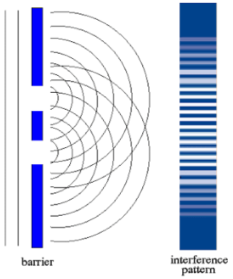
- Explain the terms diffraction and interference.
Diffraction is the spreading out of a wave after it passes an obstacle/gap
Interference occurs when waves from two sources meet to produce a wave of different amplitude.
- Explain, with the aid of a labelled diagram, how a series of bright and dark fringes were produced.
Incoming light passes through both sets of slits where it undergoes diffraction and interference.
When crests overlaps with crests we get constructive interference (bright lines on the screen).
When crests overlaps with troughs we get destructive interference (dark lines on the screen).
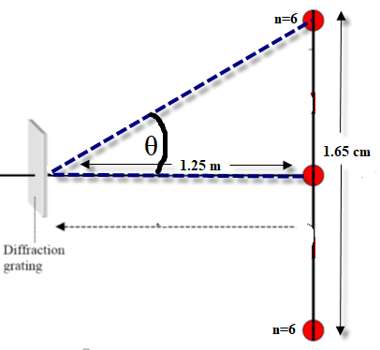
- How does this experiment demonstrate that light is a wave?
The fact that an interference pattern results can only be explained if we assume that light is wavelike in nature.
- Calculate the wavelength of the monochromatic light.
The slits are 0.5 mm apart: d = 0.5×10⁻³ m
Distance between central (n=0) image and n=6 image is 0.825 cm
$\tan{θ=\frac{opposite}{adjacent}=\frac{0.825}{125}}$ θ = 0.378⁰

$nλ=d\sin{θ}$ $λ=\frac{d\sin{θ}}{n}$

$λ=\frac{({0.5×10}^{-3} )(sin{0.378)}}{6}$ λ = 5.5×10⁻⁷ m

- List two adjustment to the apparatus that could be made to increase the distance between the bright fringes.
Increase distancebetween screen from slits, decrease distance between slits, increase wavelength
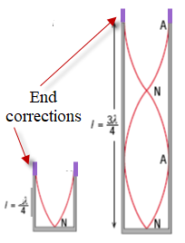
- What effect does this have on the power of the lens?
It decreases the power

- Draw diagrams to show the first two harmonics of this instrument.
See diagrams

- Calculate the wavelength of the sound wave.
There are two ways to do this.
The first is to work with the information as is:
The short pipe is 16.7 cm and is approximately ¼ of the wavelength, so wavelength = 66.8 cm
The longer pipe is 49.8 cm and this corresponds to approximately ¾ of the wavelength, so wavelength in this case = 66.4 cm.
Average wavelength = 66.6 cm
However this approach doesn’t take into account what is known as the ‘end-correction’. The antinode is slightly beyond the end of the pipe so the pipe-length doesn’t correspond to the fraction of wavelength indicated in the diagram. The alternative (correct) method is more convoluted but we need to go through it because it has also been asked in Section A and so may well get asked again.

The only way to get around this is to subtract the shorter length from the longer length. This distance corresponds to half the wavelength and the end-correction terms cancel out. See below
$$\frac{3λ}{4}=length of long pipe+end correction$$

$$\frac{λ}{4}=length of short pipe+end correction$$

$\frac{3λ}{4}- \frac{λ}{4}$ = [length of long pipe + end correction] - [length of short pipe + end correction]

$\frac{2λ}{4}$ = length of long pipe - length of short pipe {because the end correction terms cancelled out}

$\frac{λ}{2}$ = length of long pipe - length of short pipe

$\frac{λ}{2}$ = 0.498 - 0.167

$\frac{λ}{2}$ = 0.331 Answer: λ = 0.66 m

- Calculate the speed of sound in air.
$$c=fλ$$c = (512)(0.66) = 339 m s⁻¹

2019 Question 11

- Explain why the transmission of electricity using low voltage is not economical.
low voltage implies high current
High current results in more heat/energy loss than low current.
- Name the device used to (i) reduce a.c. voltage, (ii) convert current from a.c. to d.c.
(i) transformer
(ii) rectifier/diode
- State Hooke’s law.
Restoring force is proportional to displacement
Or F = - k s with correct notation
- Use Newton’s laws of motion to calculate the force exerted by the wall on the ball.
m = 0.11 kg, u = 4 m s^{–1}, v = 4 m s^{–1}, t = 0.2 s

$F=\frac{change of momentum}{time taken}$ $F=\frac{mv-mu}{t}$ $F=\frac{[(0.11)(4)]-[0.11(-4)]}{0.2}$

F = 4.4 N

- Draw a ray diagram to show the formation of an upright image in a magnifying glass.
object inside focal point of converging lens
two correct rays through lens
correct image
- Write a nuclear equation for this fission reaction.
$${Pu}_{94}^{239}+n_{0}^{1}→{Xe}_{54}^{134}+{Zr}_{40}^{103}+3n_{0}^{1}$$

- Calculate the energy released in this reaction.
Total mass beforehand |  |  | Total mass afterwards
Pu–239 | 1 neutron |  | Xe–134 | Zr–103 | 3 neutrons
239.052163 u |  |  | 133.905395 u | 102.926599 u
3.96996 × 10⁻²⁵ | 1.67493 × 10⁻²⁷ |  | 2.22355 × 10⁻²⁵ | 1.70914 × 10⁻²⁵ | 5.02478 × 10⁻²⁷
3.9867093 × 10⁻²⁵ kg |  |  | 3.98294 × 10⁻²⁵ kg
Loss in mass = 3.7715 × 10⁻²⁸ kg
E = mc² = (3.7715 × 10⁻²⁸)(2.9979 × 10⁸)²
E = 3.3896× 10⁻¹¹ J

1 atomic mass unit (1 amu) = 1.6605402×10⁻²⁷ kg
{numerical value of atomic mass unit can be found on page 47 of F&T booklet}
Neutron mass = 1.67492728 × 10⁻²⁷ kg
{numerical value of neutron unit can be found on page 46 of F&T booklet}

In hindsight I should have taken the following more straightforward method to find the loss in mass:
Begin by writing the mass of each element in terms of u.
Then subtract the total on the right hand side from the total on the left hand side.
Then convert back from u to kg.

In what form is this energy released?
kinetic energy / heat
2019 Question 12 (a)

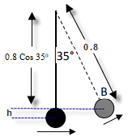
- State the principle of conversation of energy.
Energy cannot be created or destroyed but only changed from one form to another.
- Calculate the velocity of the mass at position B
$$h=0.8-(0.8Cos 35)$$
$$h=0.145$$
Total energy at position 1 = total energy at position 2
mgh + ½mv² = mgh + ½mv²
0 + ½v² = gh + ½v²
½(4)² = (9.8)(0.145) + ½v²
v = 3.63 m s⁻¹
- Calculate its centripetal acceleration at position B.
$a=\frac{v^{2}}{r}$ $a=\frac{{3.63}^{2}}{0.8}$ a = 16.5 m s⁻² towards the centre
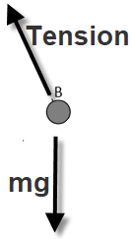
- Draw a labelled diagram to show the forces acting on the mass when it is at position B.
Weight (or mg), tension

2019 Question 12 (b)
- What is a semiconductor?
A semiconductor is a material with a resistivity between that of a conductor and an insulator
- What is meant by doping a semiconductor?
Adding an impurity (to change its conductivity)
- How can a semiconductor be doped so that its majority charge carriers are electrons?
Add an element with more outer electrons / add e.g. phosphorus
- How can a semiconductor be doped so that its majority charge carriers are holes?
Add an element with fewer outer electrons/ add e.g. boron

- Calculate the energy stored in the capacitor when it is fully charged.
$E=\frac{1}{2}CV^{2}$ $E=\frac{1}{2}C(90×{10}^{-15})({1.2)}^{2}$ E = 6.5×10⁻¹⁴ J
- Calculate the number of additional electrons that are on the negative plate of the capacitor as a result of it being fully charged.
$$Q=CV=\left({90×10}^{-15}\right)\left(1.2\right)={1.08×10}^{-13}C$$

Number of additional electrons = $\frac{{1.08×10}^{-13}}{{1.6×10}^{-19}}$ = 675000

2019 Question 12 (c)
- Explain the underlined terms.
Critical angle: angle of incidence corresponding to an angle of refraction of 90°
total internal reflection: Angle of incidence > critical angle and all light is reflected back
- Calculate the area of this disc of light.
The formula for area of a disc is πr², so we need a value for r.
First we can calculate a value for the critical angle C using
$η=\frac{1}{\sin{i_{c}}}$ $\sin{i_{c}}=\frac{1}{η}$ i_{c} = $\sin^{-1}{\frac{1}{1.33}=}$ 48.8⁰

If we know C and the depth of the diver (12 m), then we can use trigonometry to work out r.
$\tan{C= \frac{r}{12}}$ r = 12 tan C r = 13.7 m Area = πr² = π(13.7)²

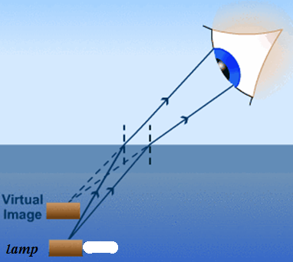
Area = 590 m²

- A diver is 12 m below the surface in a pool of water.
Use a labelled diagram to explain why the diver does not appear to be at a depth of 12 m when viewed by an observer outside the pool.
correct refracted ray
correct apparent ray / correct position of image

2019 Question 12 (d)

- Name the two families and distinguish between them.
baryon and meson
baryon has three quarks and meson has a quark and an antiquark

- The single pion produced must be neutral. Explain why.
For charge to be conserved.

- Calculate the total kinetic energy of the three particles after the collision.

Total kinetic energy of the 3 particles after = (kinetic energy beforehand) – (energy required to produce the pion)

Step 1: Calculate the kinetic energy beforehand
$${Kinetic energy}_{before}=\frac{1}{2}{mv}^{2}$$
Mass of proton = 1.6726×10⁻²⁷ kg {mass of proton available from page 47 of F&T booklet}

$${Kinetic energy}_{before}=\frac{1}{2}{{(1.6726×10}^{-27})((0.9)(2.9979×{10}^{8})}^{2}$$
${Kinetic energy}_{before}={1.2176×10}^{-10}$ J

Step 2: Calculate the energy required to produce the pion.
Energy to produce the pion: Use E = mc², where m represents the mass of the pion in kg.

Mass of π⁰ = (264)(mass of one electron) {relative mass of π⁰ available from page 48 of F&T booklet}
Mass of π⁰ = (264)(9.1094 × 10⁻³¹ kg) {mass of electron available from page 47 of F&T booklet}
Mass of π⁰ = 2.4048816×10⁻²⁸ kg
Energy to produce the pion = mc² = (2.4048816×10⁻²⁸)(2.9979 ×10⁸)² = 2.1614×10⁻¹¹ J

Energy of the 3 particles after = (kinetic energy beforehand) – (energy required to produce the pion)
Energy of the 3 particles after =$({1.2176×10}^{-10}$) – (2.4048816×10⁻²⁸)(2.9979 ×10⁸)²
Energy of the 3 particles after =$({1.2176×10}^{-10}$) – 2.1614×10⁻¹¹

Energy of the 3 particles after = 1.00 ×10⁻¹⁰ J

- How are the protons maintained in circular motion?
Using magnetic fields

- State the principal advantage of a circular accelerator over a linear accelerator.
“Greater energy can be created”
The line above is taken straight from the official marking scheme. Which isn’t overly reassuring when one considers that the answer to the first part of Question 12 (a) is that energy cannot be created. I suppose it just highlights how difficult it is to be precise with the phrases we use. We all ‘know’ what we are trying to say when we use phrases in a vague way like this and usually that’s good enough. The other thing to consider is that the marking scheme isn’t saying that they necessarily approve of this answer; just that they were prepared to award it full marks in this instance.
A better answer would be along the following lines: “So that a greater amount of kinetic energy can be transferred to mass energy of the accelerating particles”.

